**DAILY ONLINE ACTIVITIES SUMMARY**

|  |  |  |  |
| --- | --- | --- | --- |
| **Date:** | 29/05/2020 | **Name:** | Krishnitha |
| **Sem & Sec** | 4th sem, A Section | **USN:** | 4AL18CS039 |
| **Online Test Summary** | | | |
| **Subject** | Operating System | | |
| **Max. Marks** | 30 | **Score** | 28 |
| **Certification Course Summary** | | | |
| **Course** | Trailhead Basics | | |
| **Certificate Provider** | Sales force | **Duration:** | 4hrs |
| **Coding Challenges** | | | |
| **Problem Statement:**  1) Write a C Program to generate first N Armstrong Numbers.  2) Write a Java program to Find size of the largest ‘+’ formed by  all ones in a binary matrix. | | | |
| **Status:** Executed | | | |
| **Uploaded the report in GitHub** | | YES | |
| **If yes Repository name** | | <https://github.com/krishnitha/C-coding>  <https://github.com/krishnitha/Java-coding> | |
| **Uploaded the report in slack** | | YES | |

Online Test Details:

Today we had assessment in the subject Operating Systems. The test was based on second module of this subject. The second module consist of Threading concepts. There were total 30 number of questions of ONE mark each.

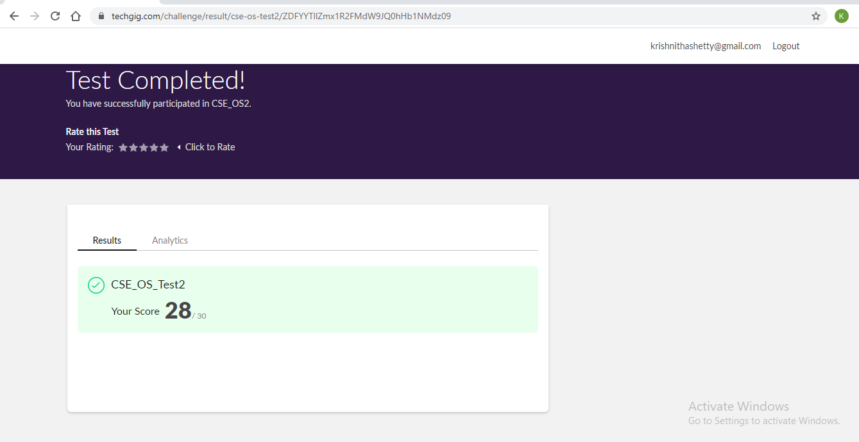

Certification Course Details:

Today I have done certification course on Trailhead Basics. I learnt about the architecture of trailhead. I also learnt how to install dashboard pal app and trailhead playground package and also, I have installed my first app in Trailhead playground. This course comprises of total 13 number of modules out of which I completed 5. And also I have earned 4 badges.



Coding Challenges Details:

Problem 1: Write a C Program to generate first N Armstrong Numbers

Armstrong number is a number that is equal to the sum of cubes of its digits. For example, 0, 1, 153, 370, 371 and 407 are the Armstrong numbers.

**Example 1:**

Let’s try to understand why 153 is an Armstrong number.

153 = (111) +(555) +(333)

where:

(111) =1

(555) =125

(333) =27

So:

1+125+27=153

Example 2:

371 = (333) +(777) +(111)

where:

(333) =27

(777) =343

(111) =1

So:

27+343+1=371

**Solution:** Uploaded it in GitHub

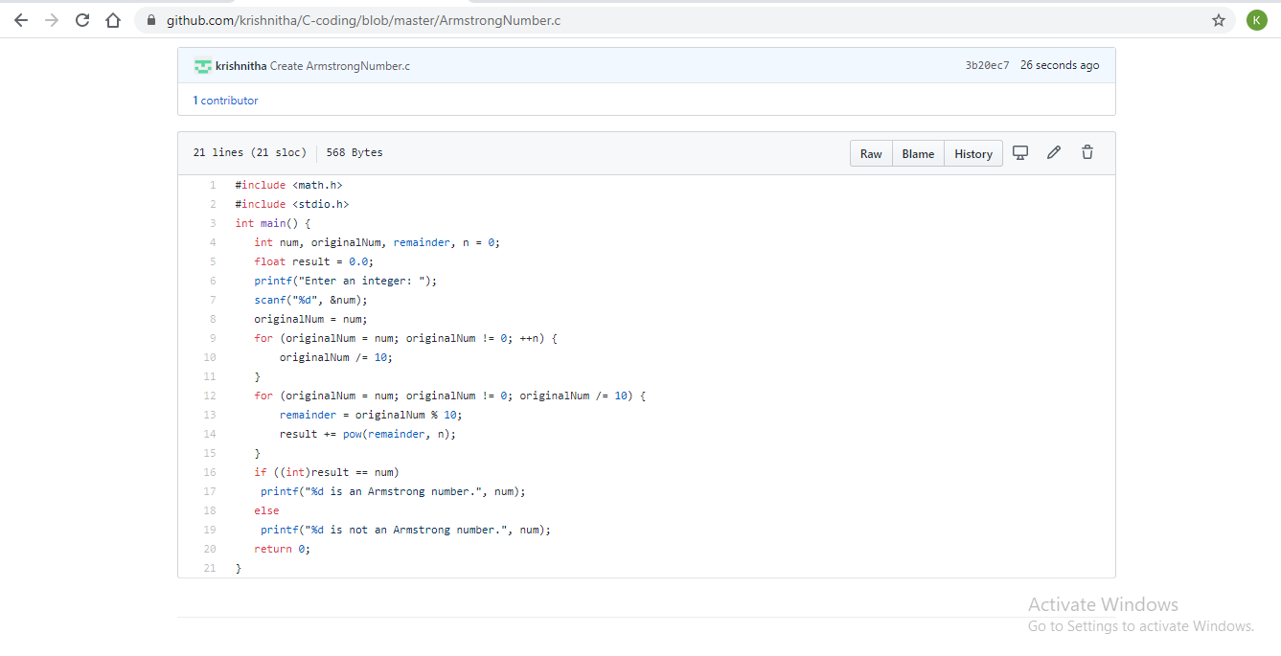

Problem 2: Write a Java program to Find size of the largest ‘+’ formed by all ones in a binary matrix.

Given a N X N binary matrix, find the size of the largest ‘+’ formed by all 1s.

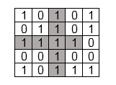

For above matrix, largest ‘+’ would be formed by highlighted part of size 8.

The idea is to maintain four auxiliary matrices left[][], right[][], top[][], bottom[][] to store consecutive 1’s in every direction. For each cell (i, j) in the input matrix, we store below information in these four matrices –

left(i, j) stores maximum number of  
consecutive 1's to the left of cell (i, j)  
including cell (i, j).

right(i, j) stores maximum number of  
consecutive 1's to the right of cell (i, j)  
including cell (i, j).

top(i, j) stores maximum number of  
consecutive 1's at top of cell (i, j)  
including cell (i, j).

bottom(i, j) stores maximum number of  
consecutive 1's at bottom of cell (i, j)  
including cell (i, j).

After computing value for each cell of above matrices, the largest + would be formed by a cell of input matrix that has maximum value by considering minimum of (left(i, j), right(i, j), top(i, j), bottom(i, j) )

**Solution:** Uploaded it in GitHub

